Assignment 3

Question 1

Dinu Wijayaweera

**Q: A record label want to predict the sales of a record (thousands of records) by the advertising budget (thousands €) promoting the record before release, airplay (times played on radio) the week before release & the attractiveness of the band (from 0 to 10). The record label has data on 200 different records/songs.**

# Step 1

We start our analysis with multi collinearity check.

When we check the correlations table we can see in the Pearson Correlation the independent variables that the r<.60 which means it is not related. Hence we can proceed to next step.

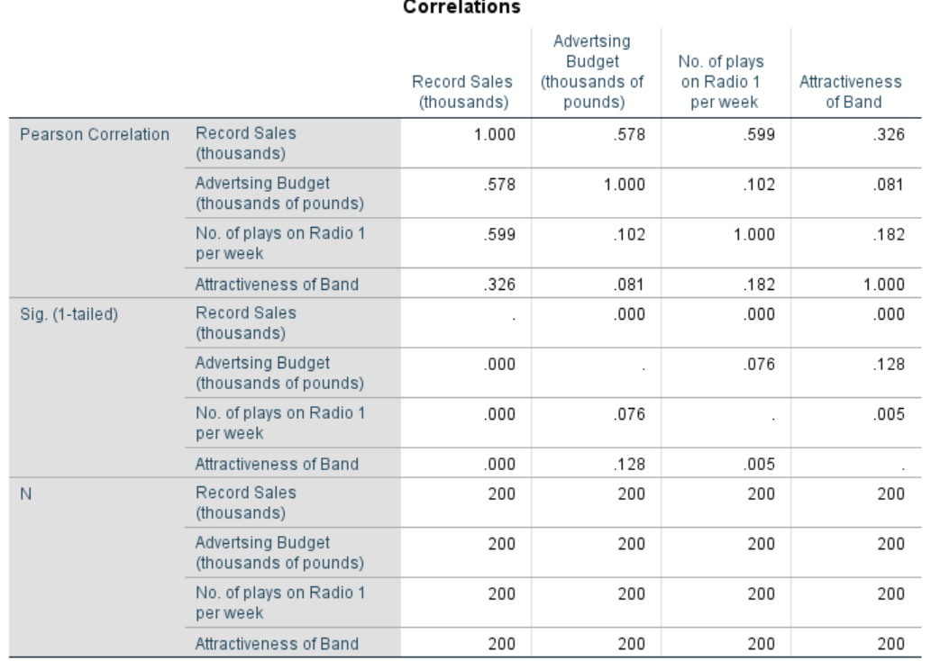

# Step 2

Next we proceed to check if there are outliers.

The table displays a number of outliers. Hence we need to proceed to remove them temporarily for the analysis.

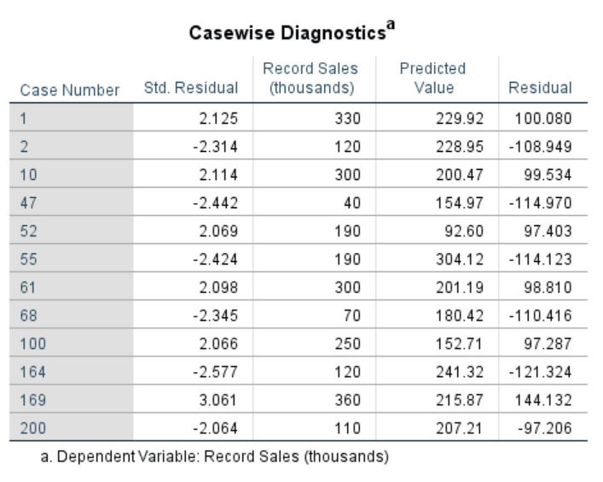

Next, we proceed to rerun the test after removing

**ANOVA Results**

Anova results displays there is high significance.

Hence it is positive that we could proceed.

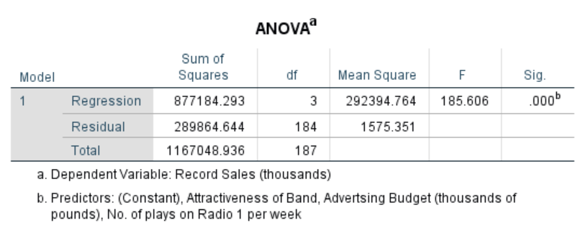

**Model Summary**

The adjusted R square is also higher than the recommended hence we can proceed to next step.

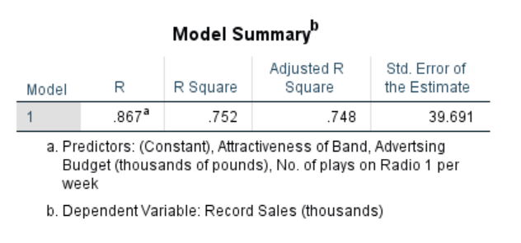

# Step 3

Derive the regression model and check the significance of the predictors.

We will be able to derive the regression model by the unstandardized coefficients to predict Record Sales.

The significance of all variables are >.20 hence we could see that all the variables have high significance. The constant (intercept) is a negative value here.

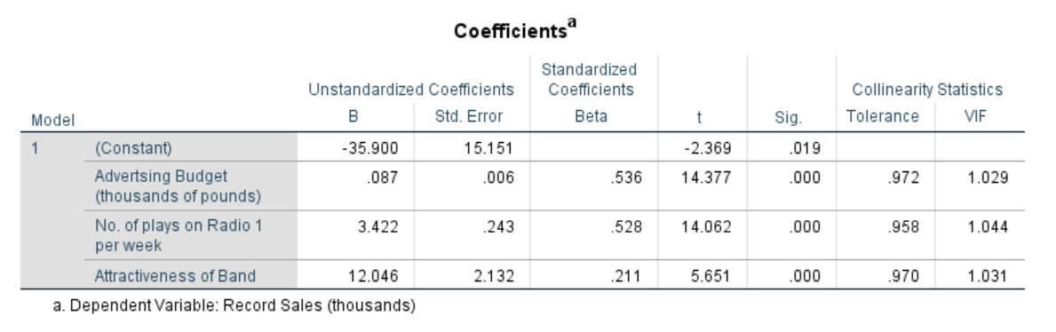

**Record Sales = -35.900+.087 Advertising Budget + 3.422 No. of plays on Radio 1 per week + 12.046 Attractiveness of the Band**

**Results**

A multiple linear regression was calculated to predict consumer satisfaction based on Advertising Budget, No. of plays on Radio 1 per week and Attractiveness of the Band. A significant regression equation was found:

(F(3, 184) = 185.6, p < .001), with an R² = .748

• **Predicted sales of a record = -35.90 + .09 Advertising Budget + 3.42 No. of plays on Radio 1 per week + 12.05 Attractiveness of the Band + ε.**

Object predicted sales increases by .09 for each unit of advertising budget, 3.42 for each number of plays on radio per week, and 12.05 for each unit of Attractiveness of the Band. All of these IVs were significant predictors of customer satisfaction (all p < .01).

According to the statistics below, you could see that there is high mean values for advertising and followed by no of plays on radio.

